**PANDIT DEENDAYAL ENERGY UNIVERSITY SCHOOL OF TECHNOLOGY**

**DEPARTMENT OF COMPUTER ENGINEERING**



**LAB MANUAL INDUSTRY 4.0 (20IF201T) B. TECH - SEMESTER V**

**NAME :**  Ravi Jamanbhai Makwana

**ROLL NO:** 21BCP418

**BATCH :** Div-6, G-12

**BRANCH:** Computer Engineering

**CERTIFICATE**

**This is to certify that roll no 21BCP418 of B.Tech 3rd year**

**Computer Engineering branch has completed the laboratory sessions for the subjects of Industry 4.0 (20IF201T) satisfactorily.**

**Subject Coordinator**

**INDEX**

|  |  |  |  |  |
| --- | --- | --- | --- | --- |
| **Sr No** | **Experiment** | **Date of submission** | **Marks obtained** | **Sign** |
| 1 |  |  |  |  |
| 2 |  |  |  |  |
| 3 | Introduction to MATLAB programming and SIMULINK |  |  |  |
| 4 | Design of smart meter for recording the electricity consumption |  |  |  |
| 5 | Design of Ultrasonic proximity sensors using Arduino |  |  |  |
| 6 |  |  |  |  |
| 7 |  |  |  |  |
| 8 |  |  |  |  |
| 9 |  |  |  |  |
| 10 |  |  |  |  |

**Experiment No: 03**

**Introduction to MATLAB programming and SIMULINK**

**Aim:** To understand the basics about MATLAB software and learn basic programming and simulation.

### Introduction

"MATLAB is a high-performance language for technical computing. It integrates computation, visualization, and programming in an easy-to-use environment where problems and solutions are expressed in familiar mathematical notation." - from Mathworks MATLAB is available on all three major operation systems.

SIMULINK is a powerful simulator for modeling and simulating dynamic systems.

One of the biggest advantages of using MATLAB is one does not need to declare ahead of time, the type of variable being used. The base version of MATLAB/SIMULINK is aptly supported by a variety of toolboxes.

The window is divided into three main parts.

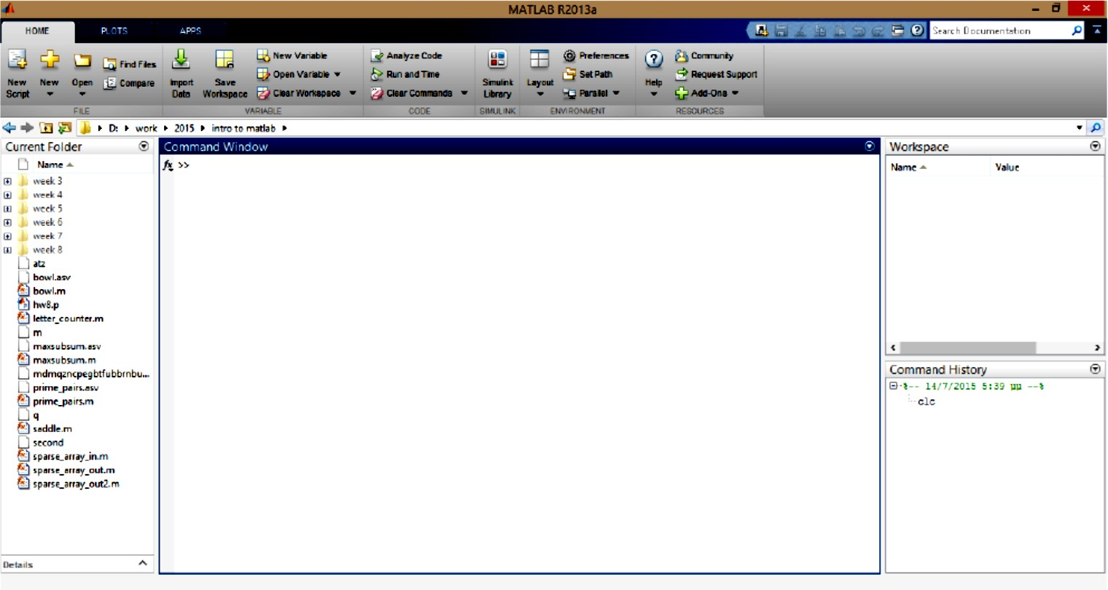

* The Command Window is the main window where the commands are input.
* The Current Directory shows the directory from which MatLab runs the files and functions we have created.
* Command History shows the history of all the commands that we input into the Command Window.
* The main menu has three different tabs, HOME, PLOTS and APPS. From the Home tab the appearance and layout of MatLab can be changed.

### Script File

A script file in MATLAB is any set of MATLAB commands which are executed in that sequence. Script files have ".m" extension. It is recommended to use a meaningful name for the filename without including "space".

A script file can be run by simply typing the filename without its extension.

The scope of the variables used in script files is the general workspace. They can be accessed even after the execution.

A script file can contain functions which can be used within that script.

MATLAB executes the script file by interpreting every line, which makes its somewhat slow at times. A script file can be put on path so that it can be called from any directory.

Note: Do not assign a script file name which is already a MATLAB in built function.

### Matrix Algebra

**Create a row vector** A = [1 3 6 8]

**Create a column vector** A = [1;3;6;8]

**Transpose of matrix** A = [1 3 6 8]’ **Or use transpose(**A)

**Create a matrix** A = [1 3; 6 8]

**Assign each element to matrix** A(1, 1) = 1; A(2, 1) = 6; A(1, 2) = 3; A(2, 2) = 8;

* Both matrices and vectors are enclosed in square brackets
* Elements are accessed using parentheses
* **For creating uniformly spaced vector** B = (0 : 1 : 99) B has 100 elements from 0 to 99 with spacing of 1.

Access first two and last two elements of B: B=([1 2 end-1 end]) Take every third element of B and store in C: C=B(1:3:end)

### Special Matrices/Array

Matlab allows to create a variety of special matrices that appear in several problems.

* **Create an Identity matrix** Imat = eye(3; 3)
* **Create a matrix of ones and zeros** A = ones(3; 3) B = zeros(3; 3)
* **Hadamard Matrix** H = hadamard(2)
* **Magic Matrix** M = magic(3)
* **Toeplitz Matrix** T = toeplitz([34]; [32])
* **Simple checks on matrices** Check if the matrix is empty A=[ ]; isempty(A)

### Check if two matrices are equal

A=exp([1 2 ; 3 4])

B=expm([1 2; 3 4])

isequal(A,B)

* Check if a matrix contains real elements

A = [1 2; 3 4]

B = ones(2; 2) C = A + j * B

isreal(C)

### Check if matrix elements are NaN (Not a Number)

A = [1 2; 3 inf]

isnan(A)

### Mathematical Operations on Matrices

Transpose of a matrix A = [1 8 3; 5 6 0] A’

### Extract triangular part

tril(A)

### Find indices of elements

find(A) find(A >= 4)

### Matrix Multiplication

A = [1 8; -5 0; 9 2] B = [2 6; 8 3; -1 5]

### Element wise multiplication: A.*B

* **Product of A and B:** A*B

### Maximum and minimum of A

max(A) min(abs(A))

* **Inverse of matrix A:** inv(A)

### Determinant of matrix A: det(A)

* **Matrix division** B B *inv(A)

### Element wise division: B./A

* **Eigen values of matrix A:** eig(A)
* **Rank of matrix A:** rank(A)
* **Characteristics equation** eqA = poly([1 2; 3 4]) roots(eqA),

Note: compare this with eigen values of A

* **LU factorization** [L,U] = lu([1 2; 3 4])
* **Orthogonalization** Q = orth([1 2; 3 4])

### Special Numbers and variables

pi: The value of pi

inf: Infinity (or a very very large number) eps: Floating point relative accuracy

i or j: Imaginary number,

NaN: Not-a-Number

ans: The most recent answer

end: The last element of a vector; OR to indicate end of a loop or a conditional statement all: Used with clear command to clear all variables

### Elementary functions

Trigonometric: sin, sinh, cos, atan, sec Exponential: exp, log, log2, pow2, sqr

Complex: abs, imag, conj, unwrap, angle Rounding: fix, floor, ceil, mod, rem, sign Specialized: bessel, beta, erf, dot, gamma Number theoretic: factor, primes, factorial, gcd

### Create 100 samples of sine and cosine

x = sin(2 *pi * 0:2 * (0 : 99)) ; y = cos(2* pi * 0:2 *(0 : 99))

**PART A: MATLAB Programming**

(1) **Sum of series 1 + 1/2 + 1/4 + 1/6 +... for 100 terms**

clc

% clear all

% sum of series 1 + 1/2 + 1/4 + 1/6 +... for 100 terms x=1; %initialising the first term

n=input('The number of terms in series to be summed:') for i=1:n

y=1/(2*i);

x=x+y;

end display(x)

**Output)**

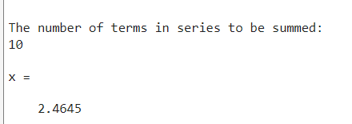

## (2) Square roots of odd positive integers

clc

%clear all

% square roots of odd positive integers:

n=input('The total number of odd positive terms whose roots are to be displayed:')

for i=1:n

y=(2*i)-1;

x(i)=sqrt(y);

end

display(x’)

**Output)**

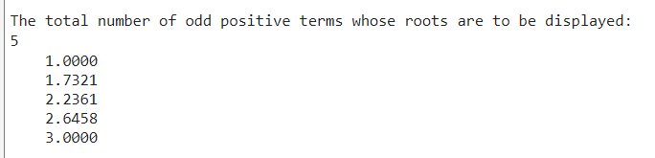

## Find the smallest ‘k’ so that 1 + 2 + 3 + ….+ k >= 30

clc

% smallest ‘k’ so that 1 + 2 + 3 + ….+ k >=30

for k=1:100

sum = k*(k+1)/2; if sum>=30

display(k)

display('is the smallest value for which sum is >= 30') break

end end

**Output)**

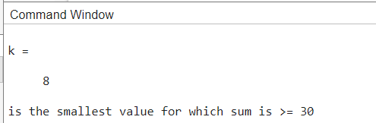

## Create a function file to input the radius & area of circle is returned as output:

% Input the radius & output area of circle: function ar=cir_area(r)

r=input('Enter the radius of the circle: ') ar=pi*r*r;

disp('Area of the circle is:')

**Output)**

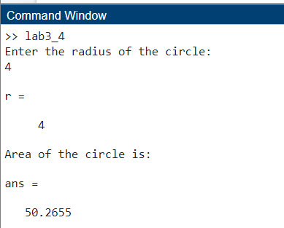

## To check whether the number is odd or even

clc

% To check whether the number is odd or even

x=input(‘Enter any number: ’) z=rem(x,2)

if z==0

display(‘The entered number is an even number.’) else

display(‘The entered number is an odd number.’) end

**Output)**

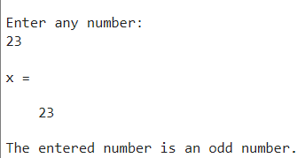

## To display all prime numbers from 50-150

clc

clear all

% display all primes from 50 to 150 x1=input('Enter the lower limit of range') % 50

x2=input('Enter the upper limit of range') % 150 y=primes(x2)

for k=1:length(y) if y(k)>50

disp(y(k)) end

end

**Output)**

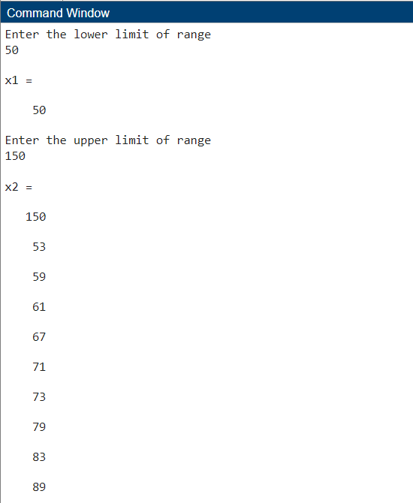

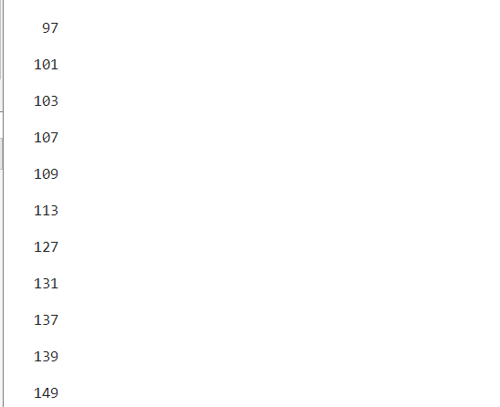

## Display if number is divisible by 100

clc

% Display if number is divisible by 100

x=input(‘Enter any number: ’) z=rem(x,100)

if z==0

disp(‘The number is divisible by 100.’)

end

**Output)**

else

disp(‘The number is not divisible by 100.’)

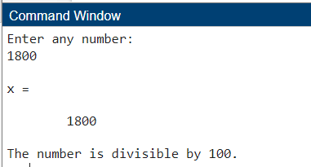

## Swap the values of given numbers

clc

% swap the values of given numbers

x1=input('Enter any number:') x2=input('Enter any number:')

a=x2; b=x1;

x1=a x2=b

sprintf('X1 is swapped by X2..!')

**Output)**

